

**A Report on Evaluation of Central Pharmaceuticals Working Capital Management**

**A Report**

**on**

**Evaluation of Central Pharmaceuticals’ Working Capital Management**



October 5, 2024

Md Erfan

Assistant Professor

Department of CSE

University of Barisal

Subject: Submission a report on “**Evaluation of Central Pharmaceuticals’s Working Capital Management”**

Dear Sir,

We are hereby submitting our report on “Evaluation of Central Pharmaceuticals Working Capital Management” as a work of our BBA program. We have given our utmost effort in making the report as informative as possible.

We are very grateful since your proper guidance helped us through to make the report as precise as possible. We hope we have been successful in following your instructions and we will also be available for any arisen clarifications or queries. Your support in this regard will be highly appreciated.

Sincerely Yours,

Md Rakibul Islam

ID No: 20 FIN 054

Department of Finance & Banking,

**Acknowledgement**

First of all, we would like to express our gratitude to almighty Allah for enabling us to complete this report on “**Evaluation of Central Pharmaceuticals Working Capital Management”**. Successfully completion of any type of report requires help from a number of persons. We have also taken help from different people for the preparation of the report. Now there is a little effort to show our deep gratitude to that helpful person. We convey our sincere gratitude to our course instructor **Md Erfan**, Assistant Professor of department of CSE, University of Barisal. Without her kind direction and proper guidance this study would have been a little success. In every phase of the report, her supervision and guidance shaped this report to be completed perfectly.

**Bona Fide Certificate**

This is certified that this report titled “**Evaluation of** **Central Pharmaceuticals Working Capital Management”** is the bona fide work of group: **“**who carried out the report under my supervision. Certified further, that to the best of my knowledge the work shown herein does not part of any other report or dissertation on the basis of which a degree or award was conferred on an earlier occasion on this or any other candidate.

Signature

Md Erfan

Assistant Professor

Department of CSE

University of Barisal

**Table of Content**

|  |  |  |
| --- | --- | --- |
| Serial | Chapter | Page no. |
| 1 | **Executive Summery** |  |
| 2 | **Chapter 1: Introduction**   * 1. : Introduction of the report   2. : Scope of the study   3. : Objective of the study   4. : Limitation of the study   1.5: Methodology  1.6: Background of the report | 8  8  8  8  9  9 |
| 3 | **Chapter 2: Overview of pharmaceutical in Bangladesh**  2.1: Company profile | 10  11 |
| 4 | **Chapter 3: Working Capital Management**  3.1: Introduction  3.2: Importance of Working Capital  3.3: Classification of Working Capital  3.4: Estimation of Working Capital  3.5: Working Capital Consideration of Textile Companies  3.6: Sources of Working Capital  3.7: Characteristics of Working Capital  3.8: Management of Working Capital  3.9: Evaluation of Working Capital | 11-12  13  13-14  14-15  15  16  16  16  17  17-20 |
| 5 | **Chapter 4: Financial Analysis – Interpretation**  4.1: Financial Analysis and Ratio | 21-27 |
| 6 | **Chapter 5: SWOT Analysis of Central Pharmaceuticals** | 28-29 |
| 7 | **Chapter 6: Conclusion & Recommendation** | 30 |
| 8 | **Reference** | 31 |

**Executive Summary**

Working capital is one of the vital elements to perform daily task in different types of business organizations. To produce the best possible returns, firms shouldn’t keep any unproductive asset and should finance with cheapest available of funds. For pharmaceutical industries, working capital management is very much necessary. In our country pharmaceutical industry is one of the most profitable sources of foreign currency. To operate a pharmaceuticals firm efficiently, the firm need management of working capital with an efficient way. Here we will discuss about “Central Pharmaceuticals’ Working Capital Management” and how they manage their working capital. We will also do SWOT analysis and draw some recommendations. We added different ratio related to working capital by evaluating last Ten year’s data of Central Pharmaceuticals’ Annual Reports. By evaluating these we will try to draw an overall image of working capital management of Central Pharmaceuticals.

**Chapter 1: Introduction**

* 1. **Introduction of the report**

Every organization irrespective of the size is required two types of financial assistance. One is long-term funds which are required primarily to acquire basic infrastructure for the company to create production facilities through purchase of fixed assets such as plant & machinery, land, building, furniture, etc. Investments in these assets represent that part of firm’s capital which is blocked on permanent or fixed basis and is called fixed capital. Funds are also needed for short-term purposes for the purchase of raw material, payment of wages and other day to day operations. These funds are known as working capital. In simple words, working capital refers to that part of the firm’s capital which is required for financing short- term or current assets such as cash, marketable securities, debtors & inventories. Funds thus invested in current assets keep revolving fast and are being constantly converted in to cash and these cash flows out again in exchange for other current assets. Hence, it is also known as revolving or circulating capital or short-term capital. In today’s competitive environment one of the primary goals of the financial management is effective utilization of available funds.

* 1. **Scope of the Study:**

The scope of the study is identified after and during the study is conducted. The main scope of the study was easy access into the internet. All the annual report was available on Central Pharmaceuticals’ website. The study of working capital is based on tools like Ratio Analysis, Statement of changes in working capital. Further the study is based on last Ten years Annual Reports of Central Pharmaceuticals.

**1.3 OBJECTIVES OF THE STUDY:**

* To study the sources and uses of the working capital.
* To study the liquidity position through various working capital related ratios.
* To study the working capital components such as receivables accounts, Cash management.
* To make suggestions based on the finding of the study.

**1.4 Limitation of the Study:**

* The Study is limited to only the last Ten year’s performance of the Company. That means present year data didn’t include in this report.
* For making a clear-cut opinion, Ratio technique of financial management has been used.
* Lack of primary data.
* Limited Sources.
  1. **METHODOLOGY:**

**Primary data collection:**

Though it’s an analyzing report but it is matter of great regret we hardly use primary data for this report. The main reason for this issue is far from the capital and that’s why we couldn’t collect any data directly and for this causes we actually depended on the secondary data.

**Secondary data collection:**

Secondary data was collected from following way:

**FGD (Focus Group Discussion):**

It is not possible to do such a report alone. We group members are really done very well when doing this report. Each and every member did their level best for completing this report efficiently. This report actually done by using internet data. We collected previous Ten year’s data from the website of the Central Pharmaceuticals.

**Books:**

We used our reference book for the guideline of this report.

**Analysis**:

1. The initial step of the Report was studying about the working capital management of Central Pharmaceuticals & then evaluating the financial position of the company on the basis of ratio analysis.
2. Comparing the firm’s financial position with last Ten year’s data of Central Pharmaceuticals with the help of following ratios:
3. Net Working Capital
4. Current Ratio
5. Quick Ratio
6. Inventory turnover Ratio
7. Inventory turnover in days
8. Inventory Conversion period
9. Account Receivable turnover
10. Average collection period
11. Cash Conversion Cycle
12. Average Payment Period

3.The project will focus on the study of overall working capital management of Central Pharmaceuticals, for which the following study analysis will be undertaken.

**Tools for Financial Calculation:**

Microsoft Excel & Microsoft Word

* 1. **Background of the report:**

We prepared the report based on the working capital management of Renata Company Ltd. according to the instruction of our course instructor (Tandra Mondal, Assistant Professor, University of Barishal). This paper identifies how much Renata Company Limited effectively uses their working capital compare with previous years and also determines their current ratio, cash ratio, cash conversion cycle to disclose their working capital management. The main object of this report is to disclose their working capital need and determine their management of working capital. This report based on the 2013-2022 annual report of Renata Company Limited. At first, compare with their previous year's activity and then compare with other corporations to discover their working capital situation and provide a meaningful solution. The result of this report indicates that working capital is mandatory and the organization should manage working capital properly and there is a positive relationship between working capital management and profit. Profitability can be earned by reducing the number of days of their account receivable turnover and inventories turnover there are still some opportunities to improve its working capital management. This study provides information about the financial situation of Renata Company Ltd. We have tried our best to show our personal observation and knowledge in this report.

**Chapter 2: Overview of pharmaceutical industries in Bangladesh**

The pharmaceutical industry in Bangladesh has experienced significant growth and development over the past few decades, making it one of the key sectors of the country's economy. Here is an overview of the pharmaceutical industry in Bangladesh:

1. **Historical Background**: The pharmaceutical industry in Bangladesh has its roots in the early 1980s when the government introduced policies to encourage domestic pharmaceutical production. Since then, the industry has evolved rapidly.
2. **Regulatory Environment**: Bangladesh's pharmaceutical sector is governed by the Drug Control Ordinance of 1982 and the Drug Rules of 1984. The regulatory authority, the Directorate General of Drug Administration (DGDA), ensures compliance with international standards.
3. **Growth and Expansion**: Bangladesh's pharmaceutical industry has grown exponentially over the years, with many local companies producing a wide range of medicines, including generic drugs and active pharmaceutical ingredients (APIs). This growth is driven by factors such as a large domestic market, cost-effective production capabilities, and export opportunities.
4. **Export Market**: Bangladesh is one of the largest suppliers of generic medicines in the world. The country exports pharmaceutical products to more than 150 countries, including the United States, Europe, and Asia. This has contributed significantly to the industry's global reputation and economic growth.
5. **Quality Standards**: To maintain international quality standards and regulatory compliance, many Bangladeshi pharmaceutical companies have obtained certifications such as the World Health Organization's Good Manufacturing Practice (GMP) certification.
6. **Research and Development**: The pharmaceutical industry in Bangladesh has been investing in research and development (R&D) to develop new formulations and improve existing products. Some companies have set up dedicated R&D centers to support innovation.
7. **Local and Multinational Companies**: Bangladesh has a mix of local and multinational pharmaceutical companies operating in the country. While local companies dominate the market, multinational pharmaceutical companies have also established a presence and contribute to the industry's growth.
8. **Affordability**: One of the key advantages of the pharmaceutical industry in Bangladesh is its ability to produce high-quality medicines at lower costs, making healthcare more affordable for the local population.
9. **Challenges**: The industry faces various challenges, including the need for continuous investment in R&D, ensuring consistent quality, and addressing issues related to intellectual property rights and counterfeiting.
10. **Future Prospects**: The pharmaceutical industry in Bangladesh is expected to continue growing due to increasing healthcare needs, expanding export opportunities, and a commitment to quality and innovation.

In summary, the pharmaceutical industry in Bangladesh has evolved into a thriving sector, both domestically and internationally. It has played a vital role in improving access to affordable healthcare in the country and has established itself as a competitive player in the global pharmaceutical market.

**2.1 Company profile:**

Central Pharmaceuticals is one of the top ten pharmaceutical manufacturers in Bangladesh. Renata is engaged in the manufacture and marketing of human pharmaceutical and animal’s health products. The company also manufactures animal therapeutics nutrition products. Renata currently employs 2300 people in its head office in Mirpur, Dhaka and its two production facilities in Mirpur, Dhaka and Rajendrapur, Dhaka. The company began its operations as Pfizer (Bangladesh) Limited in 1972. For the next two decades, it continued as a subsidiary of Pfizer Corporation. However, by the late 1990s the focus of Pfizer had shifted from formulations to research. In accordance with this transformation, Pfizer divested its interest in many countries, including Bangladesh. At present, Renata Ltd. manufacturers 300 generic pharmaceutical products including hormones, contraceptives, anti-cancer drugs, oral preparations, cephalosporin, parenteral preparations as well as other conventional drugs. In addition, they also offer about 95 animal therapeutics and nutrition products. Renata Ltd. is a publicly traded company on the Dhaka Stock Exchange (DSE). In 2015, company’s annual turnover was about US $56 million, with an annual growth of about 35%. The company also operates four other manufacturing unitsthe original Pfizer facility for general products, a UNICEF –approved SFF, a Cephalosporin facility and a Penicillin facility. Renata Ltd. exports its product to UK, Afghanistan, Sri Lanka, Cambodia, Hong Kong, the Philippines, Jordan, Vietnam, Myanmar, Kenya, Belize, Nepal, Malaysia and Guyana, with registration ongoing in 23 other countries.

**Central Pharmaceuticals– Mission & Vision:**

“To provide maximum value to our customers, shareholders, colleague and communities where we live and work.” “To establish Renata permanently among the best of innovative branded generic companies.” “The endurance of a company’s reputation depends upon the quality of work it does rather than the quantities. Hence, the appreciation of quality must be instinctive and our commitment instinctive.”

**Central Pharmaceuticals- Values:**

* Focus on long-term growth.
* Structural innovation for sharing growth.
* Going the extra miles for employees.
* Environmental activism.
* Health activism through promoting innovation and partnership.

divided into 2,000,000 ordinary shares of Tk. 100 each. The Company commenced its commercial operation in 2009. The principal activities of the Company are manufacturing, marketing and distribution of all kinds of consumer goods, consumer durables, food items, edible oils and so on and to engage in the business as traders, importers, exporters, commission agents of all kinds of goods and services including pharmaceutical products. Central Pharmaceuticals holds 99.99% of equity interest in Purnava Limited.

**Chapter 3: Working Capital Management**

**3.1 INTRODUCTION:**

Capital is the keynote of economic development. In this modern age, the level of economic development is determined by the proportion of capital available.

**Meaning of Capital:** In the ordinary sense of the word Capital means initial investment invested by businessman or owner at the time of commencing the business. Capital (economics), a factor of production that is not wanted for itself but for its ability to help in producing other goods.

**Definition:** Capital is a factor of production with a specific, changeable value attached to it that could, potentially, provide its owner with more wealth. It is an abstract economic concept, and, as such, has many different definitions and classifications, but the unifying feature of capital is that it has a certain value, so it in itself is a type of wealth, and it has the potential of generating more wealth.

**Features of Capital:** Capital has the following features.

1. Capital is a man made.

2. Capital is a perishable.

3. Capital is a human control possible.

4. Capital is a mobile.

5. Capital is a human sacrifice.

6. Capital is a scarce.

7. Capital is a passive factor.

**Introduction of Working Capital:** Working capital could be defined as the portion of assets used in current operations. The movements of the funds from capital to income and profits and back to working capital are one of the most important characteristics of the business. This cyclical operation is concerned with utilization of the funds with the hope that will return with an additional amount called income. If the operations of the company are to run smoothly, a proper relationship between fixed capital and current capital has to maintain. Sufficiently liquidity is important and must be achieved and maintained to provide that funds to pay off obligation as they arise. The adequacy of cash and other current assets together with their efficient handling, virtually determine the survival of demise of the company. A businessman should be able to judge the accurate requirement of working capital and should be quick enough to raise the enquired funds to finance he working capital needs. Working capital is also called as net current assets, “it is the excess of current assets over current liabilities.” All organization has to carry working capital. It is important from the point of view of both liquidity and profitability. Poor management of working capital means that funds that unnecessarily tied up in idle assets hence educing liquidity and also reducing ability to invest in productive assets such as plant and machinery. So, affecting profitability.

The term working capital refers to current assets, which may be defined as:

* Those which are convertible into cash or equivalents with the period of one year
* Those which are required to meet day to day operations The fixed as well as current assets, both requires investment of ‘Funds’.

So the management of working capital and fixed assets apparently seem to involve it type of consideration but it is no so. The management of working capital involve different concept and methodology than the techniques used in fixed assets management.

**3.2 IMPORTANCE OF WORKING CAPITAL:**

* **Solvency of the business:** Adequate working capital helps in maintaining the solvency of the business by providing uninterrupted of production.
* **Goodwill:** Sufficient amount of working capital enables a firm to make prompt payments and makes and maintain the goodwill.
* **Easy loans:** Adequate working capital leads to high solvency and credit standing can arrange loans from banks and other on easy and favorable terms.
* **Cash discounts:** Adequate working capital also enables a concern to avail cash discounts on the purchases and hence reduces cost.
* **Regular Supply of Raw Material:** Sufficient working capital ensures regular supply of raw material and continuous production.
* **Regular payment of salaries, wages and other day to day commitments:** It leads to the satisfaction of the employees and raises the morale of its employees, increases their efficiency, reduces wastage and costs and enhances production and profits.
* **Exploitation of favorable market conditions:** If a firm is having adequate working capital then it can exploit the favorable market conditions such as purchasing its requirements in bulk when the prices are lower and holdings its inventories for higher prices.
* **Ability to Face Crises:** A concern can face the situation during the depression.
* **Quick and regular return on investments:** Sufficient working capital enables a concern to pay quick and regular of dividends to its investors and gains confidence of the investors and can raise more funds in future.

**3.3 Classification of working capital:**

1. On the basis of concept.
2. On the basis of time.
3. On the basis of concept working capital is classified into two types:
4. Net working capital
5. Gross working capital

**1.Net Working Capital:** Term Net working capital can be defining in two way

1. It is the difference between current assets and current liabilities.
2. Amount left for operational requirement.

**2.Gross Working Capital:** Gross working capital means the total current assets. And on the basis of time working capital may be classified as:

* Permanent working capital
* Temporary working capital

**1.Permanent Working Capital:** It is the minimum amount of the current assets, which are needs to conduct the business even during the dullest season of the year. This amount varies from year to year depending upon the growth of a company and stage of the business cycle in which it operates. It is the amount of funds required to produce the goods and services, which are necessary to satisfy demand at a particular point. It represents the current assets, which are required on a continuing basis over the year. It is maintained as the medium to carry on operation at any time. Permanent working capital has following features:

1. It is classified on the basis of the time factor.
2. Its size increases with the growth of the business.
3. It is constantly shifted from one asset to another and continues to remain in the business process.

**2.Temporary Working Capital:** It represents the additional assets, which are required at different times during the operating year. Seasonal working capital is the additional amount of current assets particularly cash, receivables, and inventory which is required during the more active business seasons of the year. It is the temporary investment in the current assets and possesses the following features:

1. It is not always gainfully employed, though it may also shift from one asset to another as permanent working capital does.
2. It is particularly suited to business of seasonal on cyclical nature.

**3.4 ESTIMATION OF WORKING CAPITAL REQIUREMENTS:**

Managing the working capital is a matter of balance. The firms must have sufficient funds on hand to meet its immediate needs. are manufacturing oriented organization.

The following aspects have to be taken into consideration while estimating the working capital requirements. They are:

1. Total costs incurred on material, wages and overheads.
2. The length of time for which raw material are to remain in stores before they are issued for production.
3. The length of the production cycle or work-in-process, i.e., the time taken for conversion of raw material into finished goods.
4. The length of sales cycle during which finished goods to be kept waiting for sales.
5. The average period of credit allowed to customers.
6. The amount of cash required paying day-today expenses of the business.
7. The average amount of cash required to make advance payments.
8. The average credit period expected to be allowed by suppliers.
9. Time lag in the payment of wages and other expenses.

**3.5 Working Capital Consideration of these industries:**

There are two concepts of working capital one is gross working capital and net working capital. Gross working capital is the total of all current assets. The constituents of current assets are shown in the part A in table 1 and current liabilities are shown in the part B in the table 1 the alternate definition of net working capital is the portion of a firm’s current assets that are financed with short-term fund.

|  |
| --- |
| **TABLE 1:** CONSTITUENTS OF CURRENT ASSETS AND CURRENT LIABILITIES |
| **PART- A: CURRENT ASSETS**  Inventories Raw materials and components  Work-in-progress  Finished goods Others  Trade debtors Loan and advances  Investment Cash and bank balance  **PART-B: CURRENT LIABILITIES**  Sundry creditors  Trade advances Borrowings From  - Commercial banks  -Others Provision |

**3.6 Sources of Working Capital:**

Mainly there are two sources of working capital:

1. Permanent or Fixed working capital
2. Temporary or variables working capital

In any concern, a part of the working capital investments is as investment in fixed assets. This is so because there is always a minimum level of current assets, which are copiously required by the enterprise to carry out its day-to-day business operation and this minimum, cannot be expected to reduce at any time. This minimum level of current assets need long term working capital, which is permanently blocked. Similarly, some amount of working capital may be required to meet the seasonal demands and some special exigencies such as rise in prices, strikes, etc. this gives rise to short term working capital which is required for day to day transaction also. The fixed proportion of working capital should be generally financed from the fixed capital sources while the temporary or variable working capital equipment may be met from the short term sources of capital.

**3.7 CHARACTERSTICS OF WORKING CAPITAL:**

In the management of working capital two characteristics of current assets must be borne in mind: (i) short life span, and (ii) swift transformation into other current asset forms. Current assets have a short life span. The life span of current assets depends upon the time required in the activities of procurement, production, sales and collection and the degree of synchronization among them. Each current asset is swiftly transformed into other current asset forms: Cash is used for acquiring raw materials and raw materials are transformed into finished goods (this transformation may involve several stages of work-in-progress).

* Conversion of cash into raw materials.
* Conversion of raw materials into work in progress.
* Conversion of work in progress into finished stock.
* Conversion of finished stock into accounts receivables (Debtors) through sale and
* Conversion of account receivables into cash.

**3.8 Management of working capital:**

Working capital, in general practice, refers to him excess of current assets over current liabilities. Management of working capital therefore, is concened with problems that arise in attempting to manage him current assets, current libilities, and interrelationship that exists between them. In other word it refers to all aspects of administration of both current assets and current liabilities. The basic goal of working capital management is to manage the current assets and current liabilities of a firm in such way that a satisfactory level of working capital is maintained, i.e. neither inadequate nor excessive. This is so because both inadequate as well as excessive working capital position is bad for the business. Inadequacy of working capital, may lead the firm insolvency and excessive working capital implies idle funds, which earn no profit for the business. Working capital management policies of the firm have a great effect on its profitability, liquidity and structural health of the organization. In this context, working capital management is three-dimensional nature:

1. Dimension I is concerned with the formulation of the policy with regard to Profitability, risk and liquidity.
2. Dimension II is concerned with the decision about his composition and level of current assets.
3. Dimension III is concerned with the decision about his composition and level of current liabilities.

**3.9 Evaluation of working capital:**

The working capital management needs attention of all the finance head/ working capital management is important fo voiding unnecessary blockage of fund. Like that liquidity is important at it refer to the short-term financial strength of company. It is very important to have proper balance in regard to the liquidity of the firm.

For details information of working capital of Central Pharmaceuticals please turn over to the following page

**Data implication:**

Data is used for various ratios and analyses. At first various ratios have been detected and find their working capital and show the impact. As well as compare with another company in the same industry. And all data are collected from the company's annual reports from the year 2012-2022.

**Table- 1: Current Assets**

|  |  |  |  |  |  |  |  |  |  |  |
| --- | --- | --- | --- | --- | --- | --- | --- | --- | --- | --- |
| Year | 12-13 | 13-14 | 14-15 | 15-16 | 16-17 | 17-18 | 18-19 | 19-20 | 20-21 | 21-22 |
| Inventories | 124,418,0454 | 2736490324 | 2585917388 | 3674892178 | 36238392135 | 3,361,710,600 | 3,229,222,893 | 3,757,761,605 | 4,172,321,022 | 5,126,624,240 |
| Trade receivables | 17,561,1933 | 5789327802 | 3829163728 | 6372819463 | 2748319417 | 2,029,259,467 | 1,995,758,417 | 2,232,499,238 | 2,265,753,666 | 2,543,784,315 |
| Other receivables | 15,561,6853 | 349824783 | 378291278 | 271849327 | 367281942 | 760,474,958 | 793,117,602 | 903,726,174 | 1,086,389,221 | 1,015,276,977 |
| Advances, deposits and prepayments | 4,227,68762 | 278942726 | 463281948 | 873261736 | 264738294 | 234,064,598 | 295,949,018 | 461,385,755 | 433,302,071 | 533,580,314 |
| Short-term Investment | 764924533 | 367492733 | 295819467 | 46372819 | 267483275 | 108,193,744 | 804,899,466 | 1,509,177,933 | 3,581,402,024 | 4,721,102,257 |
| Cash and cash equivalents | 287490325 | 356297245 | 346879623 | 367894201 | 263261875 | 450,611,442 | 617,236,028 | 1,057,352,468 | 798,213,039 | 1,372,995,830 |
| Current Assets | **347573205** |  | **7899353432** | **11607089724** | **40149476938** | **6,944,314,809** | **7,736,183,424** | **9,921,903,173** | **12,337,381,043** | **15,313,363,933** |

**Table- 2: Current Liabilities**

|  |  |  |  |  |  |  |  |  |  |  |
| --- | --- | --- | --- | --- | --- | --- | --- | --- | --- | --- |
| Year | 12-13 | 13-14 | 14-15 | 15-16 | 16-17 | 17-18 | 18-19 | 19-20 | 20-21 | 21-22 |
| Short-term  bank loans |  |  |  |  |  | 2,598,322,461 | 1,968,852,024 | 2,389,428,525 | 2,562,606,715 | 2,981,137,076 |
| Long-term  loan-current  portion |  |  |  |  |  | 156,800,003 | 161,200,000 | 99,662,486 | - | - |
| Trade Payables |  |  |  |  |  | 281,252,786 | 180,070,553 | 222,346,097 | 568,382,613 | 508,513,913 |
| Accruals |  |  |  |  |  | 509,252,776 | 681,270,985 | - | - | - |
| Provisions &  liabilities |  |  |  |  |  | 512,443,278 | 649,415,862 | - | - | - |
| Others payable |  |  |  |  |  | - | - | 958,330,267 | 681,214,066 | 1,212,206,130 |
| Unclaimed  Dividend |  |  |  |  |  | 16,758,740 | 26,585,338 | - | - | - |
| Provision for  Taxation |  |  |  |  |  | 945,454,055 | 749,176,975 | 805,538,964 | 800,430,247 | 1,360,352,448 |
| Current  Liabilities |  |  |  |  |  | **5,020,284,099** | **4,416,571,737** | **4,475,306,339** | **4,612,633,641** | **6,062,209,567** |

Statement of changes in the working capital is prepared to show the changes in the working capital among these. This statement is prepared with the help of the current asset and current liabilities. So,

* An increase in current asset increases working capital
* A decrease in current assets decreases in working capital
* An increase in current liabilities decreases working capital.
* A decrease in current liabilities increase working capital It is worth noting that schedule of changes in working capital is prepared only from current assets and current liabilities and the other information is not of any use for preparing this statement. The company should look in to the proper current liabilities.

Top of Form

**Chapter 4: Financial Analysis – Interpretation**

**4.1FINANCIAL ANALYSIS:**

**1. Net Working Capital:** Net working capital is the aggregate amount of all current assets and current liabilities. It is used to measure the short-term liquidity of a business, and can also be used to obtain a general impression of the ability of company management to utilize assets in an efficient manner.

Here are the main objectives of net working capital management:

* Sufficient Liquidity
* Risk Mitigation
* Efficient Operations
* Strategic Growth
* Supplier and Creditor Relationships
* Cash Flow Management
* Interest Cost Reduction:
* Optimize Inventory Levels
* Accounts Receivable Management
* Profitability
* Investor and Creditor Confidence

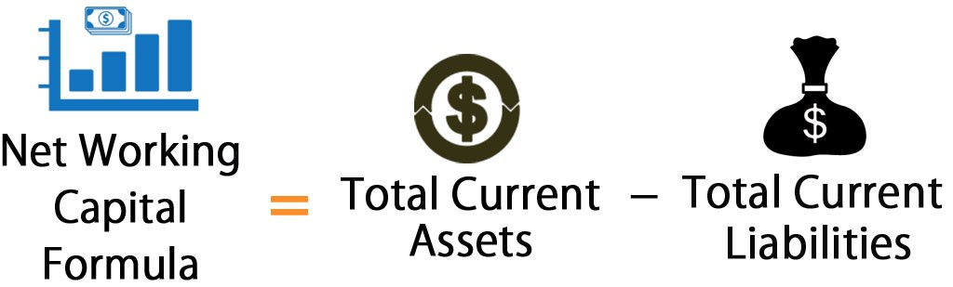

**Net Working Capital of Renata Company Ltd.**

|  |  |  |  |  |  |  |  |  |  |  |
| --- | --- | --- | --- | --- | --- | --- | --- | --- | --- | --- |
| Year | 12-13 | 13-14 | 14-15 | 15-16 | 16-17 | 17-18 | 18-19 | 19-20 | 20-21 | 21-22 |
| Net Working Capital | 4550322084 | 3858846601 | 85630054840 | 1  255768507 | 1906628853 | 1924036710 | 3319611687 | 5446596834 | 7724747399 | 9251154363 |

**Interpretation:** This figure shows net working capital from 2012-13 to 2021-22, they took more working capital. By observing this table easily find out that their working capital management is good, they properly manage working capital for this they could face short-term Obligations.

**2. Current Ratio:** The current ratio is a liquidity ratio that measures a company's ability to pay short-term obligations or those due within one year.

Here are the main objectives of Current Ratio:

* Assess Short-Term Liquidity
* Evaluate Financial Health
* Determine Creditworthiness
* Measure Operational Efficiency
* Plan for Short-Term Needs
* Gain Investor Confidence
* Support Strategic Decision-Making
* Facilitate Comparative Analysis
* Manage Financial Risk
* Aid in Budgeting and Forecasting

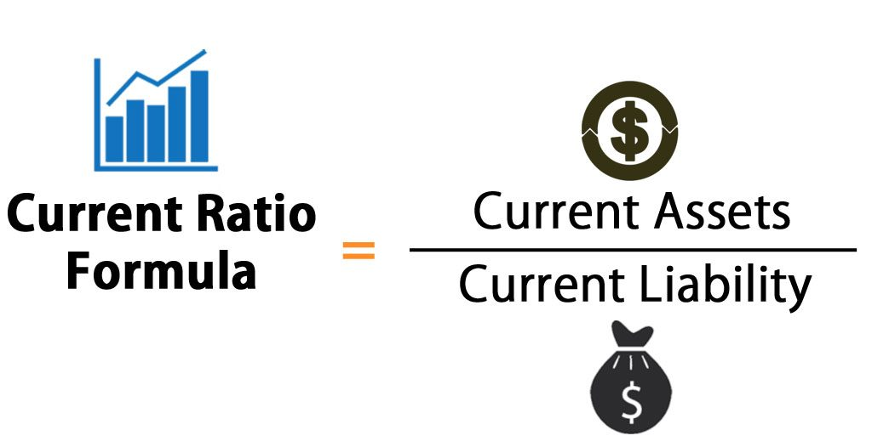

**Current Ratio of Renata Company Ltd.**

|  |  |  |  |  |  |  |  |  |  |  |
| --- | --- | --- | --- | --- | --- | --- | --- | --- | --- | --- |
| Year | 12-13 | 13-14 | 14-15 | 15-16 | 16-17 | 17-18 | 18-19 | 19-20 | 20-21 | 21-22 |
| Current Ratio | 1.113 | 0.72 | 1.09 | 0.78 | 1.02 | 1.38 | 1.75 | 2.22 | 2.67 | 2.53 |

**Interpretation:** Renata company has $1.113 current assets for every $1 current liabilities in 2012 and it decreases in 2013 to $ 0.72, again it increases in 2014 to $ 1.09 then again it decreases to $ 0.78 in 2015 and then it sequencely increases day by day to $ 1.015, $ 1.38, $ 1.75, $ 2.22, $ 2.67 in year 2016,2017,2018,2019 and 2020 respectfully. But in year 2021, it decreases to $ 2.53.

Now, we can see that the overall outlook of these ratio of all the year is not good for a company.

**3.Quick Ratio:** The quick ratio is the barometer of a company's capability and inability to pay its current obligations.

Here are the main objectives of Current Ratio:

* Assess Short-Term Liquidity
* Evaluate Financial Health
* Determine Creditworthiness
* Measure Operational Efficiency
* Plan for Short-Term Needs
* Gain Investor Confidence
* Support Strategic Decision-Making
* Facilitate Comparative Analysis
* Manage Financial Risk
* Aid in Budgeting and Forecasting

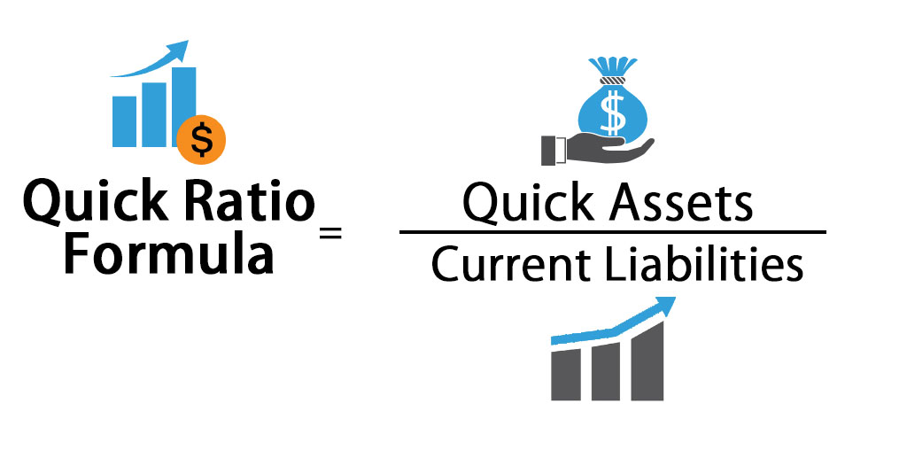

**Quick Ratio of Renata Company Ltd.**

|  |  |  |  |  |  |  |  |  |  |  |
| --- | --- | --- | --- | --- | --- | --- | --- | --- | --- | --- |
| Year | 12-13 | 13-14 | 14-15 | 15-16 | 16-17 | 17-18 | 18-19 | 19-20 | 20-21 | 21-22 |
| Quick Ratio | 0.42 | 0.26 | 0.44 | 0.29 | 0.49 | 0.55 | 1.02 | 1.38 | 1.77 | 1.68 |

**Interpretation:** Renata company has $ 0.42 current assets for every $ 1 current liabilities excluding inventories in 2012, it decreases to $ 0.26 in 2013, again it increases to $ 0.44 in 2014. Again it decreases to $ 0.29 in 2015. And, further that it increases $ 0.49, $ 0.55, $ 1.02, $ 1.38, $ 1.77 in 2016, 2017, 2018, 2019 and 2020 respectfully. But again it decreases to $ 1.68 in 2021. So, it indicates the probability to the firm.

**4.Inventory turnover Ratio:** Inventory turnover measures how efficiently a company uses its inventory by dividing the cost of goods sold by the average inventory value during the period.

Here are the main objectives of Inventory turnover Ratio:

* Evaluate Inventory Management
* Optimize Working Capital
* Identify Slow-Moving Inventory
* Improve Cash Flow
* Support Pricing Strategy
* Detect Operational Inefficiencies
* Monitor Supply Chain Performance
* Enhance Profitability
* Facilitate Comparisons
* Support Strategic Decision-Making

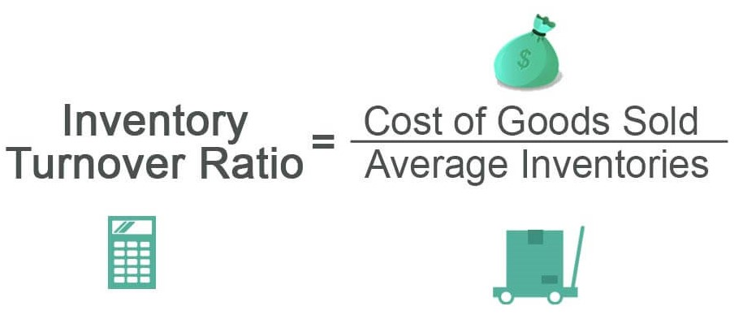

**Inventory turnover Ratio of Renata Company Ltd.**

|  |  |  |  |  |  |  |  |  |  |  |
| --- | --- | --- | --- | --- | --- | --- | --- | --- | --- | --- |
| Year | 12-13 | 13-14 | 14-15 | 15-16 | 16-17 | 17-18 | 18-19 | 19-20 | 20-21 | 21-22 |
| Inventory turnover Ratio | 1.85 | 1.96 | 1.82 | 1.62 | 1.96 | 2.07 | 2.41 | 2.65 | 2.79 | 2.72 |

**Interpretation:** Reneta company convert its inventories $1.85 times in 2012 to its cost of goods sold. In 2013 is $1.96 times, in 2014 is $1.82 times, in 2015 is 1.62 times, in 2016 is $1.96 times, in 2017 is $2.07 times, in 2018 is $2.41 times, in 2019 is $2.65 times, in 2020 is $2.79 times and in 2021 is &2.72 times inventories can be converted to its cost of goods sold.

**5.Inventory turnover in days:** Inventory turnover (days) is an activity ratio, indicating how many days a firm averagely needs to turn its inventory into sales.

Here are the main objectives of Inventory turnover in days:

* Efficient Inventory Management
* Optimize Working Capital
* Identify Slow-Moving Inventory
* Cash Flow Management
* Pricing Strategy Support
* Operational Efficiency Assessment
* Supply Chain Performance Monitoring
* Strategic Decision-Making
* Inventory Holding Cost Calculation
* Compliance and Norms Adherence
* Seasonal Adjustments

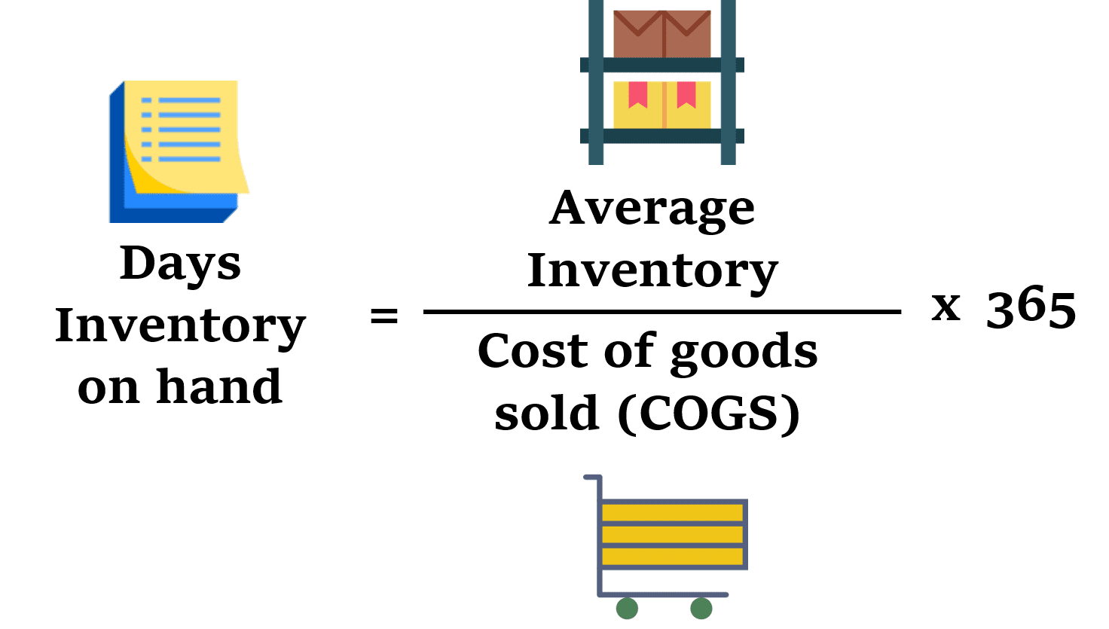

**Inventory turnover in days of Renata Company Ltd.**

|  |  |  |  |  |  |  |  |  |  |  |
| --- | --- | --- | --- | --- | --- | --- | --- | --- | --- | --- |
| Year | 12-13 | 13-14 | 14-15 | 15-16 | 16-17 | 17-18 | 18-19 | 19-20 | 20-21 | 21-22 |
| Inventory turnover in days | 128.40 | 122.56 | 134.55 | 124.60 | 125.45 | 127.32 | 123.94 | 120.55 | 122.90 | 132.40 |

**Interpretation:** We can see that Reneta Company’s inventory turnover is 128.40 days, 122.56 days, 134.55 days, 124.60 days, 125.45 days, 127.32 days, 123.94 days, 120.55 days, 122.90 days and 132.40 days in year 2012-2013, 2013-2014, 2014-2015, 2015-2016, 2016-2017, 2017-2018, 2018-2019, 2019-2020, 2020-2021, 2021-2022 respectfully. The overall outlook of the ratio of all the year is very high is not good for a company.

**6. Inventory Conversion period:** Inventory conversion period refers to the time elapsed during which a company must invest cash while it converts materials into sale.

Here are the main objectives of Inventory Conversion period:

* Evaluate Efficiency
* Working Capital Management
* Identify Slow-Moving Inventory
* Cash Flow Improvement
* Pricing Strategy
* Operational Efficiency
* Supply Chain Performance
* Strategic Decision-Making
* Holding Cost Calculation
* Compliance and Norms
* Seasonal Adjustments
* Customer Satisfaction

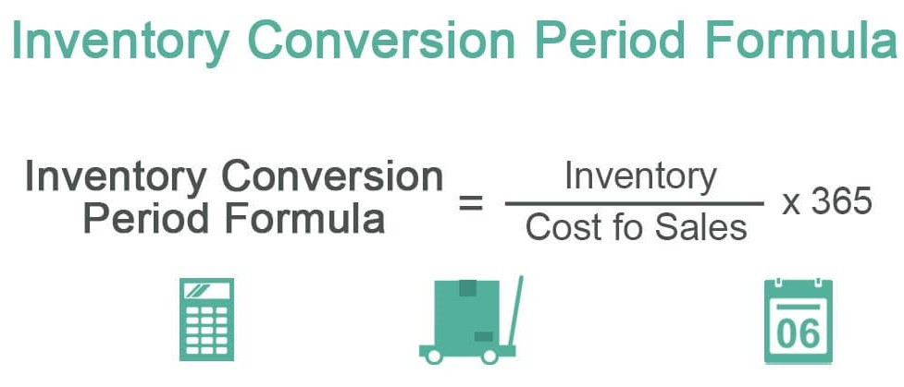

**Inventory conversion period of Renata Company Ltd.**

|  |  |  |  |  |  |  |  |  |  |  |
| --- | --- | --- | --- | --- | --- | --- | --- | --- | --- | --- |
| Year | 12-13 | 13-14 | 14-15 | 15-16 | 16-17 | 17-18 | 18-19 | 19-20 | 20-21 | 21-22 |
| Inventory Conversion period | 87.59 | 197.59 | 221.65 | 183.67 | 94.30 | 173.90 | 149.38 | 135.85 | 129.03 | 132.35 |

**Interpretation:** Reneta limited company’s inventory conversation period is 87.59 days, 197.59 days, 221.65 days, 183.67 days, 94.30 days, 173.90 days, 149.38 days, 135.85 days, 129.03 days, 132.35 days in year 2012-2013, 2013-2014, 2014-2015 ,2015-2016, 2016-2017, 2017-2018, 2018-2019, 2019-2020, 2020-2021, 2021-2022 respectfully. In year 2014-2015, it rises at a glance but in year 2019-2020 it decreasing treands day by day. So, we can tell that the overall outlook of this ratio is decreasing treands.

**7. Account Receivable turnover:** The accounts receivables turnover ratio measures the number of times a company collects its average accounts receivable balance.

Here are the main objectives of Account Receivable turnover:

* Assess Efficiency
* Optimize Cash Flow
* Identify Credit Policies
* Working Capital Management
* Liquidity Assessment
* Credit Risk Evaluation
* Strategic Decision-Making
* Customer Relationship Management
* Financial Performance Analysis
* Efficiency Improvement Benchmark
* Risk Mitigation
* Credit Policy Adjustment
* Monitor Collection Efforts

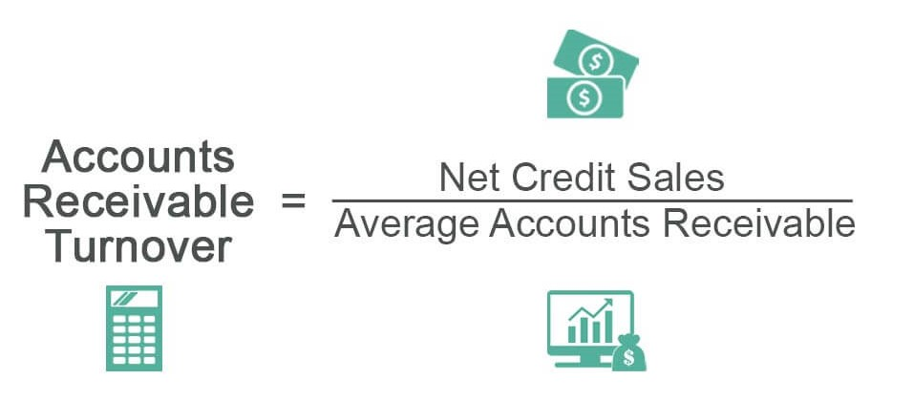

**Account Receivable turnover of Renata Company Ltd.**

|  |  |  |  |  |  |  |  |  |  |  |
| --- | --- | --- | --- | --- | --- | --- | --- | --- | --- | --- |
| Year | 12-13 | 13-14 | 14-15 | 15-16 | 16-17 | 17-18 | 18-19 | 19-20 | 20-21 | 21-22 |
| Account Receivable turnover | 9.09 | 7.66 | 8.19 | 7.35 | 6.99 | 8.11 | 8.04 | 8.33 | 9.81 | 9.50 |

**Interpretation:** Reneta limited company’s accounts receivable turnover are 9.09, 7.66, 8.19, 7.35, 6.99, 8.11, 8.04, 8.33, 9.81, 9.50 times in year 2012-2013, 2013-2014, 2014-2015, 2015-2016, 2016-2017, 2017-2018, 2018-2019, 2019-2020, 2020-2021, 2021-2022 respectfully. It indicates Reneta Limited Company’s operation has been financially efficient in 2020-2021. But it is not good for a company.

Top of Form

**8. Average collection period:** Average collection period refers to the amount of time it takes for a business to receive payments owed by its clients in terms of accounts receivable (AR).

Here are the main objectives of Average collection period:

* Assessing Liquidity
* Working Capital Management
* Credit Policy Evaluation
* Cash Flow Forecasting
* Risk Assessment
* Performance Measurement
* Customer Relationship Management
* Debt Management
* Investor Confidence
* Strategic Decision Making

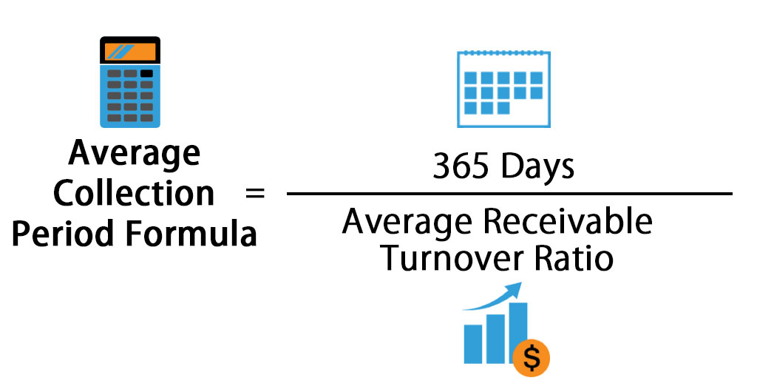

**Average collection period of Renata Company Ltd.**

|  |  |  |  |  |  |  |  |  |  |  |
| --- | --- | --- | --- | --- | --- | --- | --- | --- | --- | --- |
| Year | 12-13 | 13-14 | 14-15 | 15-16 | 16-17 | 17-18 | 18-19 | 19-20 | 20-21 | 21-22 |
| Average collection period | 39.56 | 46.97 | 43.22 | 48.93 | 51.44 | 45.00 | 45.40 | 45.11 | 37.22 | 38.41 |

**Interpretation:** Renata company limited average collection period is 39.561 days, 46.97 days, 43.22 days, 48.93 days, 51.44 days, 45.00 day 45.40 days, 45.11 days, 37.22 days and 38.42 days in year 2012-13, 2013-2014, 2014-2015, 2015-2016, 2016-2017, 2017-2018, 2018-2019, 2019-2020,2020-2021, 2021-2020 respectfully. This graph shows decreasing trends from 2018-19 up to 2021-2022. Accordingly, it means company total assets are not much active to generate profit.

**9. Cash Conversion Cycle:** The cash conversion cycle is the amount of time a company needs or takes to convert funds invested in production and sales to cash.

Here are the main objectives of Cash Conversion Cycle:

* Working Capital Efficiency
* Liquidity Management
* Cost Reduction
* Cash Flow Forecasting
* Performance Measurement
* Identifying Bottlenecks
* Optimizing Credit and Payment Terms
* Risk Assessment
* Strategic Decision Making
* Investor and Stakeholder Confidence

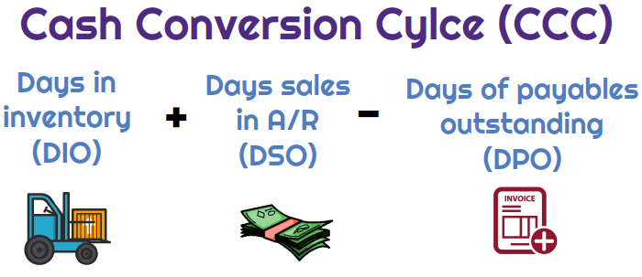

**Cash Conversion Cycle of Renata Company Ltd.**

|  |  |  |  |  |  |  |  |  |  |  |
| --- | --- | --- | --- | --- | --- | --- | --- | --- | --- | --- |
| Year | 12-13 | 13-14 | 14-15 | 15-16 | 16-17 | 17-18 | 18-19 | 19-20 | 20-21 | 21-22 |
| Cash Conversion Cycle | 32.09 | 31.89 | 37.30 | 43.76 | 56.87 | 45.00 | 45.40 | 45.11 | 37.22 | 38.42 |

**Interpretation:** Reneta company conversion cycle is $32.09, $31.89, $37.30, $43.76, $56.87, $45.00, $45.40, $45.11, $37.22, $38.42 in year 2012 to 2021 respectfully. It indicates Reneta company operation has been financially efficient in 2016.But it is not good for a company.

**10. Average Payment Period:** Average payment period is the metric used to represent the average number of days a company takes to pay the amount payable to its supplier.

Here are the main objectives of Average Payment Period:

* Cash Flow Management
* Liquidity Assessment
* Supplier Relationship Management
* Cost Management
* Creditworthiness
* Cash Conservation
* Strategic Decision Making
* Financial Planning
* Risk Mitigation
* Performance Measurement

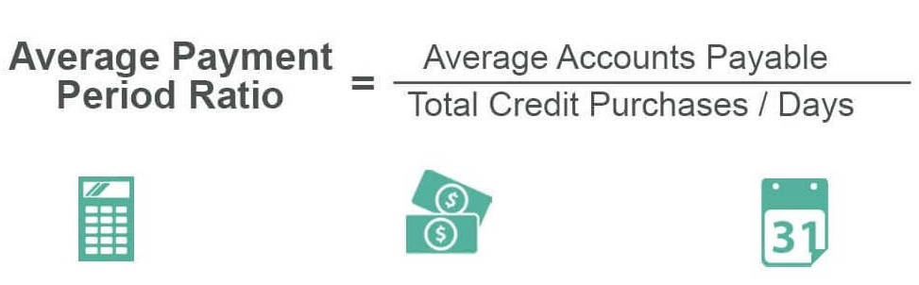

**Average Payment Period of CENTRAL PHARMACEUTICALSLtd.**

|  |  |  |  |  |  |  |  |  |  |  |
| --- | --- | --- | --- | --- | --- | --- | --- | --- | --- | --- |
| Year | 12-13 | 13-14 | 14-15 | 15-16 | 16-17 | 17-18 | 18-19 | 19-20 | 20-21 | 21-22 |
| Average Payment Period | 4.82 | 5.91 | 4.64 | 5.49 | 8.40 | 7.09 | 7.33 | 16.42 | 12.13 | 14.10 |

**Interpretation:** Central Pharmaceuticals company's average payment period presents increasing trends. It rises in 2019-2020 up to 2021-2022 accordingly, it means company's average payment period is good to generate profit.

**Chapter 5: SWOT Analysis of Central Pharmaceuticals**

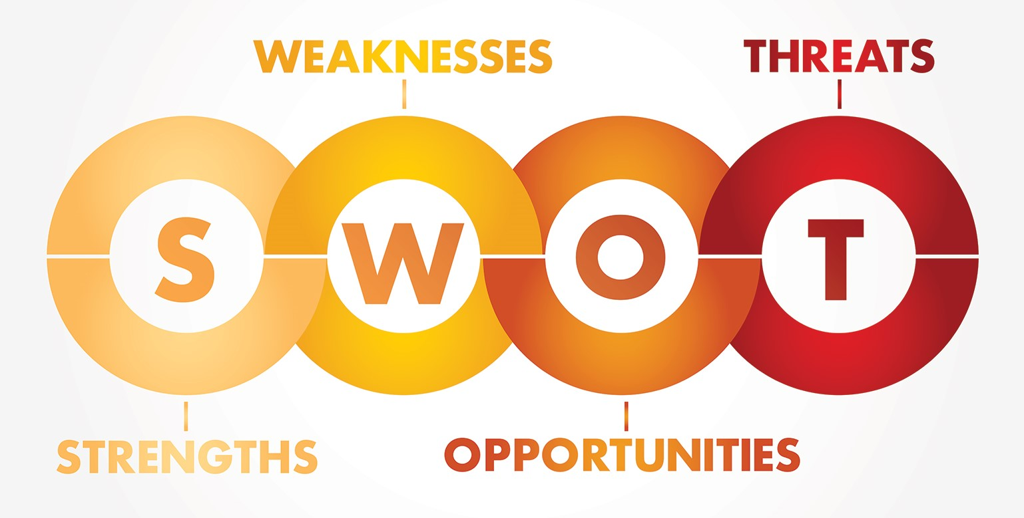

**SWOT Analysis:**

A SWOT analysis is overall evaluation of the company’s Strengths, Weakness, Opportunities and Threat. Strengths and Weakness are internal value creating (or destroying) factors such as assets skills or recourses etc. And Opportunities and thereat are external value creating (or destroying) factors a company can’t control.

**Strengths of Renata Ltd.:**

* The large portion of this company established in their own land.
* This company is well equipped with skilled, and expertise and productive manpower. They are doing timely shipment and 100% perfect quality.
* Ability to cope with the change.
* Attractive pay package.
* They arranged required raw materials as per requirements of their valued buyers and provide samples on specific queries in a very quicker way.
* Experienced management team.
* Good working condition.
* Modern technology.
* Innovative product line.
* They are corresponding with buyers firstly.
* World wide.

**Weakness of Renata Ltd.:**

* Short of marketing expertise.
* Lacking accountability.
* Number of employee is not so much.
* Need to require proper coordination with different section.
* Delay in payment from supplier.
* Conflict and working load are seen.
* The subordinate are not taking any decision or policy making meeting. The decision always comes from Managing director.
* Location of the factory.
* Power centralization by the top management.
* Nepotism and corruption are available.
* **Opportunities of Renata Ltd.:**
* Developing market area ( EU, USA, China, etc.)
* They can lead against weak competitor.
* They always try to higher dynamic young people so that output will come more.
* Attain different trade fare and get new idea related with today’s business.
* They can give extra facility to gain customers satisfaction.
* The students as customers through some special offers.
* Scope of expansion on of business.
* **Thereat to Renata Ltd.:**
* Government tax and vat structure.
* In Bangladesh, so many companies are there. For that reason, buyer are offering lower price.
* Competitor offer and new innovative substitute products.
* Increased trade barriers and quota system withdrawn.
* Delay of payment from buyer creates some times bad situation of company’s liquidity and future financial budget plan.
* Strike (Hartal)
* Skilled employee switching.

**Chapter 6: Conclusions & Recommendation**

Renata Company Ltd. is one of the important companies in the Bangladesh pharmaceutical industry. It holds a favorable market share. Their management is also very efficient. They have a sound relationship with their stakeholder. This report is based on working capital management. Working capital is important to maintain the overall health condition of an organization. And run an organization smoothly working capital is needed. The various formulas have been used to determine their working capital management. Analyzing the financial performance is so much important as it reveals the overall finance scenario of a company. In this case of Renata company limited, the financial performance of this company is getting weak day by day. The current scenario of financial performance of this company is the worse comparing the previous 10 years. The company is playing a great role in the economic development of Bangladesh. But the company is facing a lot of challenges as it is going through a good level of financial leverage. To overcome these challenges, the company needs to improve the financial sectors. Government support in needed for improvement their financial leverage. The company should make every movement by forecasting its result as it has a lot of financial leverage.

**Here are the main key points of Conclusion of Renata Ltd.:**

1. The current ratio of finance limited is not a good position. It has not enough ability to play off its current liabilities with it's current assets.

2. The quick ratio of Renata company limited is so high day by day. It indicates the probability of the firm.

3. The inventory turnover ratio also consistently increasing year by year. It means, Renata company limited gaining its ability to generate enough profit and value for shareholders.

4. The cash conversion cycle of Renata company limited is decreasing year by year. It has been financially efficient in 2016-2017. But, It is not good for a company.

5. The net working capital of finance limited is a good position. They properly manage working capital for this they could face short term obligations.

**Recommendation:**

We would like to recommend on the following areas that’s should be help to achieve the goals of Renata Ltd. Generally they should give concentration on marketing strategy and as well as performance evaluation process.

Here are the main key points:

* Identify the market segmentation efficiently, then setting their target market and forecast which market offering more opportunity.
* Renata’s marketing department must try to understand the buyer needs, wants and demands.
* Need to develop long term relationship with key parties-buyers, buying house and suppliers
* To achieve the goals, Renata’s marketing team need to establish effective marketing mix (product, price, promotion and place)
* Today’s business world moving very first by the digital revolution. The impact of the digital revolution and it can implement data based marketing
* Survey on buyer intentions regarding plant, equipment, raw materials, place, compliance etc.
* Identify their position based on the product life cycle and position of their competitors, and then take a corrective action.

**References:**

* Annual Reports of Central Pharmaceuticals (<http://www.renata-ltd.com/>)
* Principles of Managerial Finance –Lawrence J. Gitman, Chad J. Zutter.
* Baños-Caballero, S., García-Teruel, P. J., & Martínez-Solano, P. (2014). Working capital management, corporate performance, and financial constraints. Journal of Business Research, 67(3), 332-338
* www.google.com
* <https://corporatefinanceinstitute.com/resources/knowledge/finance/cash-conversion-ratio/>
* Modern working capital management – Frederick C. Scherr